The Great British Week of Sport
21st- 25th September

This week Exercise Therapy are celebrating The Great British Week of Sport by organising a different sporting event each day (Monday-Friday). If you would like to get involved or find out more information please speak to the Exercise Therapy team. Sessions will be held on the outdoor pitch.
Monday Cricket

Tuesday Volleyball

Wednesday National Fitness Day
Test Your Fitness- Rowing Challenge

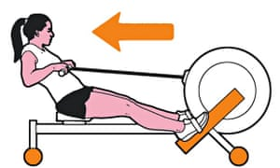

Thursday Orienteering

Friday Football

