

**1 Mile A Day**

**Your Way**

**Ideas How You Can Achieve This?**





**22 Laps**

**Around The**

**Ward**

**This does not need to be completed all at once, this can be completed throughout the day for example:**

**5 laps on a morning/ 6 laps before lunch / 5 laps before dinner/ 6 laps on an evening**

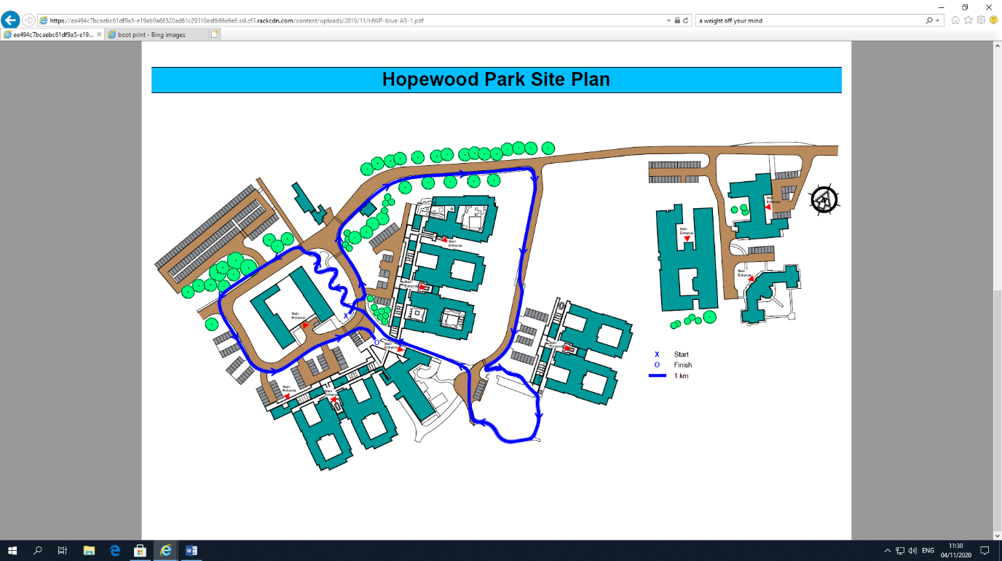

**2 Laps Of**

**The Blue**

**Route**



Guide for completion times

**High intensity = under 10 minutes**

**Moderate = 10-12minutes**

**Light = 12+ minutes**

The route has numerous gentle inclines and declines. You’ll be

Walking on pavements and walking trails so please ensure you have the appropriate footwear.



**1 Mile A Day**

**Your Way**

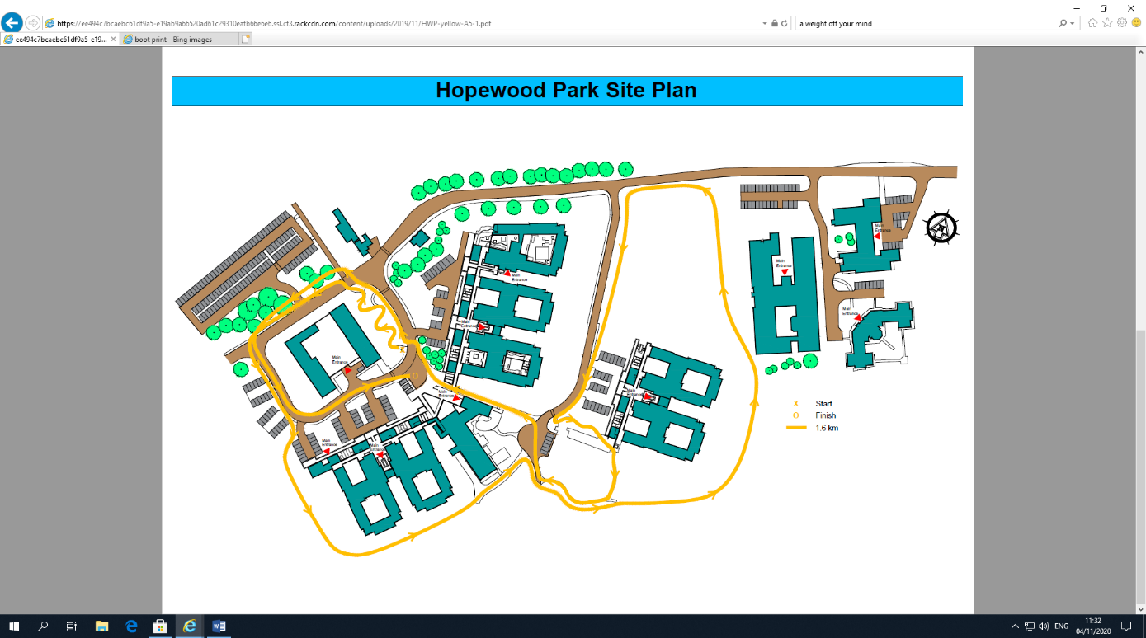



**1 Lap Of**

**The Yellow**

**Route**

Guide for completion times

**High intensity = under 17 minutes**

**Moderate = 17-20 minutes**

**Light = 20+ minutes**

The route has numerous gentle inclines and declines. You’ll be walking on pavements and walking trails so please ensure you have the appropriate footwear.

4 Week Challenge

|  |  |  |  |  |  |  |  |
| --- | --- | --- | --- | --- | --- | --- | --- |
| **Week** | **Monday** | **Tuesday** | **Wednesday** | **Thursday** | **Friday** | **Saturday** | **Sunday** |
| **1** |  |  |  |  |  |  |  |
| **2** |  |  |  |  |  |  |  |
| **3** |  |  |  |  |  |  |  |
| **4** |  |  |  |  |  |  |  |

**Tick when complete**